**LAB4**

**Jimmy Palma**

**610756**

1. **Determine whether InsertionSort, BubbleSort, SelectionSort are *stable* sorting algorithms, and in each case, explain your answer.** 
   1. BubbleSort is stable because the line that compares the values is

if(*arr[i] > arr[i+1]) swap(i, i+1)*

En el case the values are the same, after sorting the value arr[i] will be before arr[i+1]. Example: [5₁, 5₂, 4] -> [5₁, 4, 5₂] -> [4, 5₁, 5₂]

* 1. SelectionSort is not stable because this algorithm swap the positions and it lose the original positions. Example: [5₁, 5₂, 4] -> [4, 5₂, 5₁]
  2. InsertionSort is stable because after sorting the value arr[i] will be before arr[i+1].Example: [7| 5₁, 5₂, 4] -> [5₁, 7| 4, 5₂] -> [4, 5₁, 7|, 5₂] -> [4, 5₁, 5₂, 7]

1. **Perform the MergeSort algorithm by hand on the array [7, 6, 5, 4, 3, 2, 1]. Show all steps.**

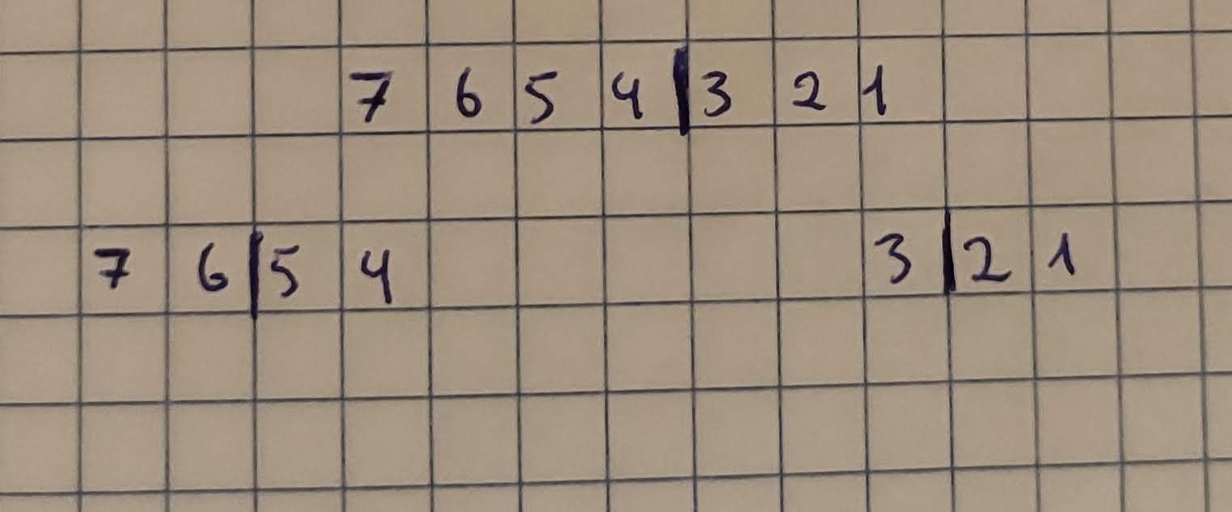

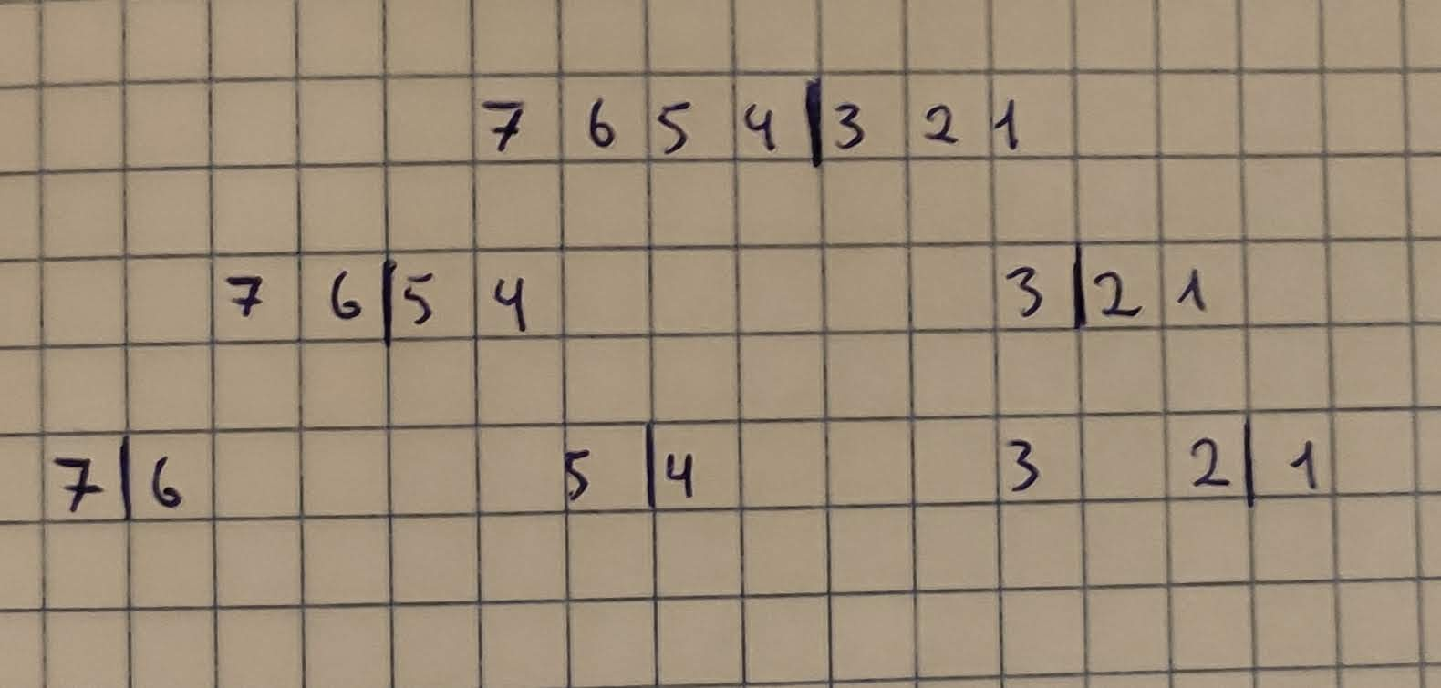

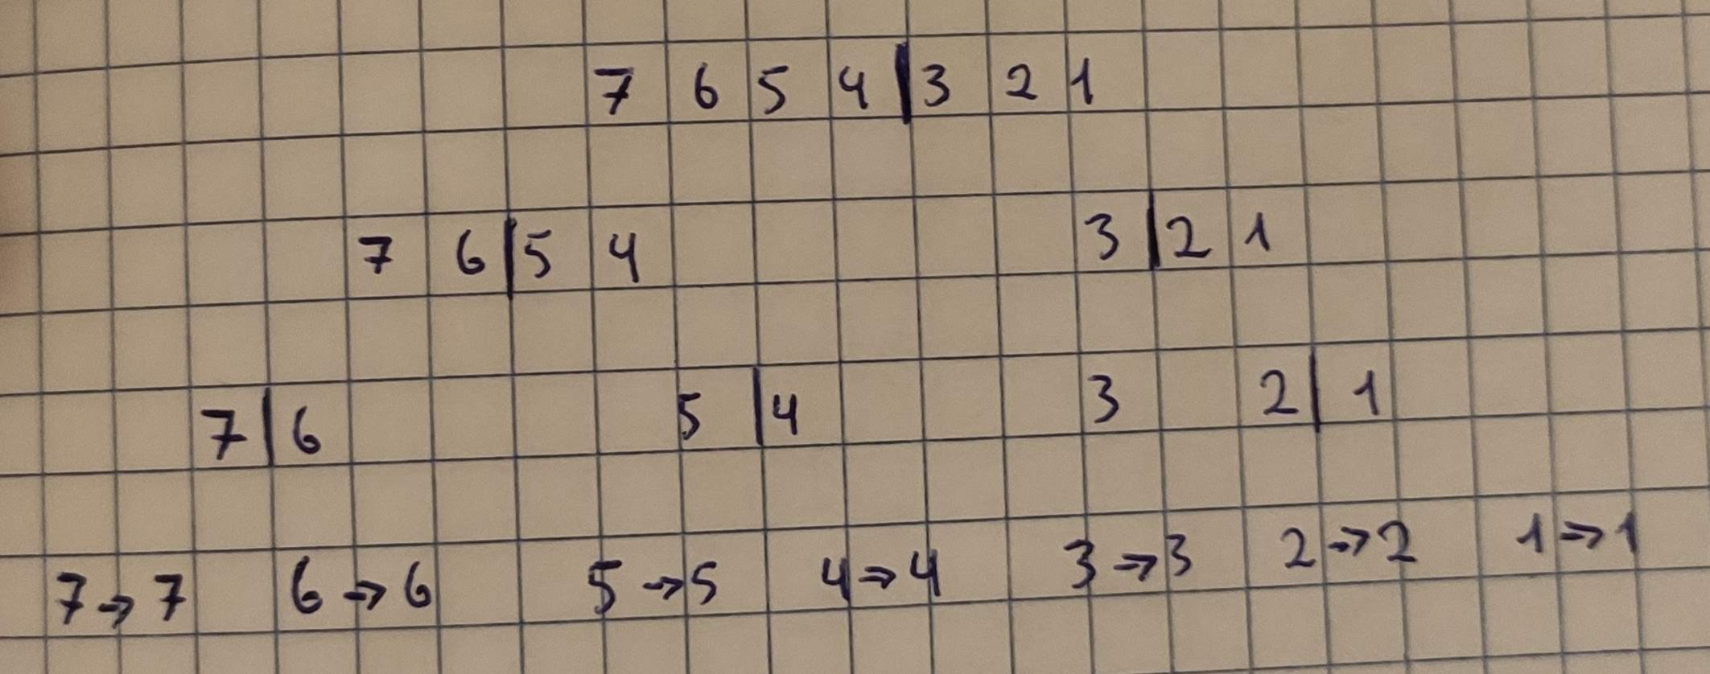

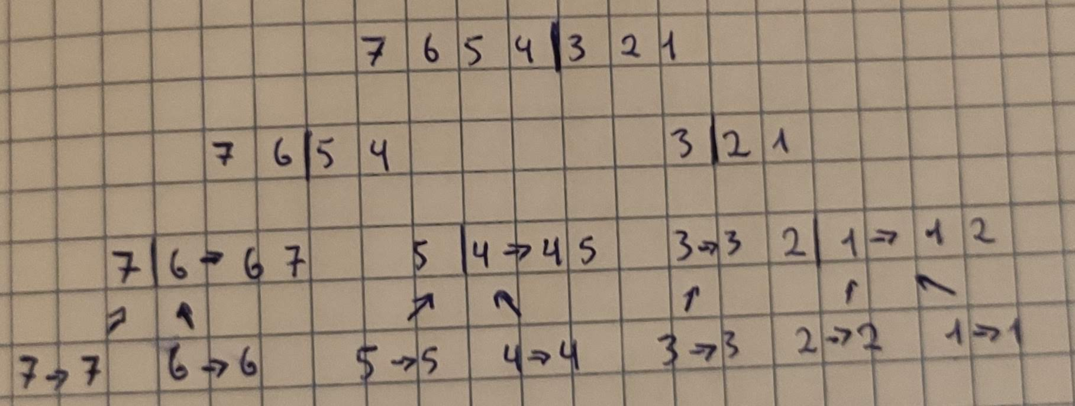

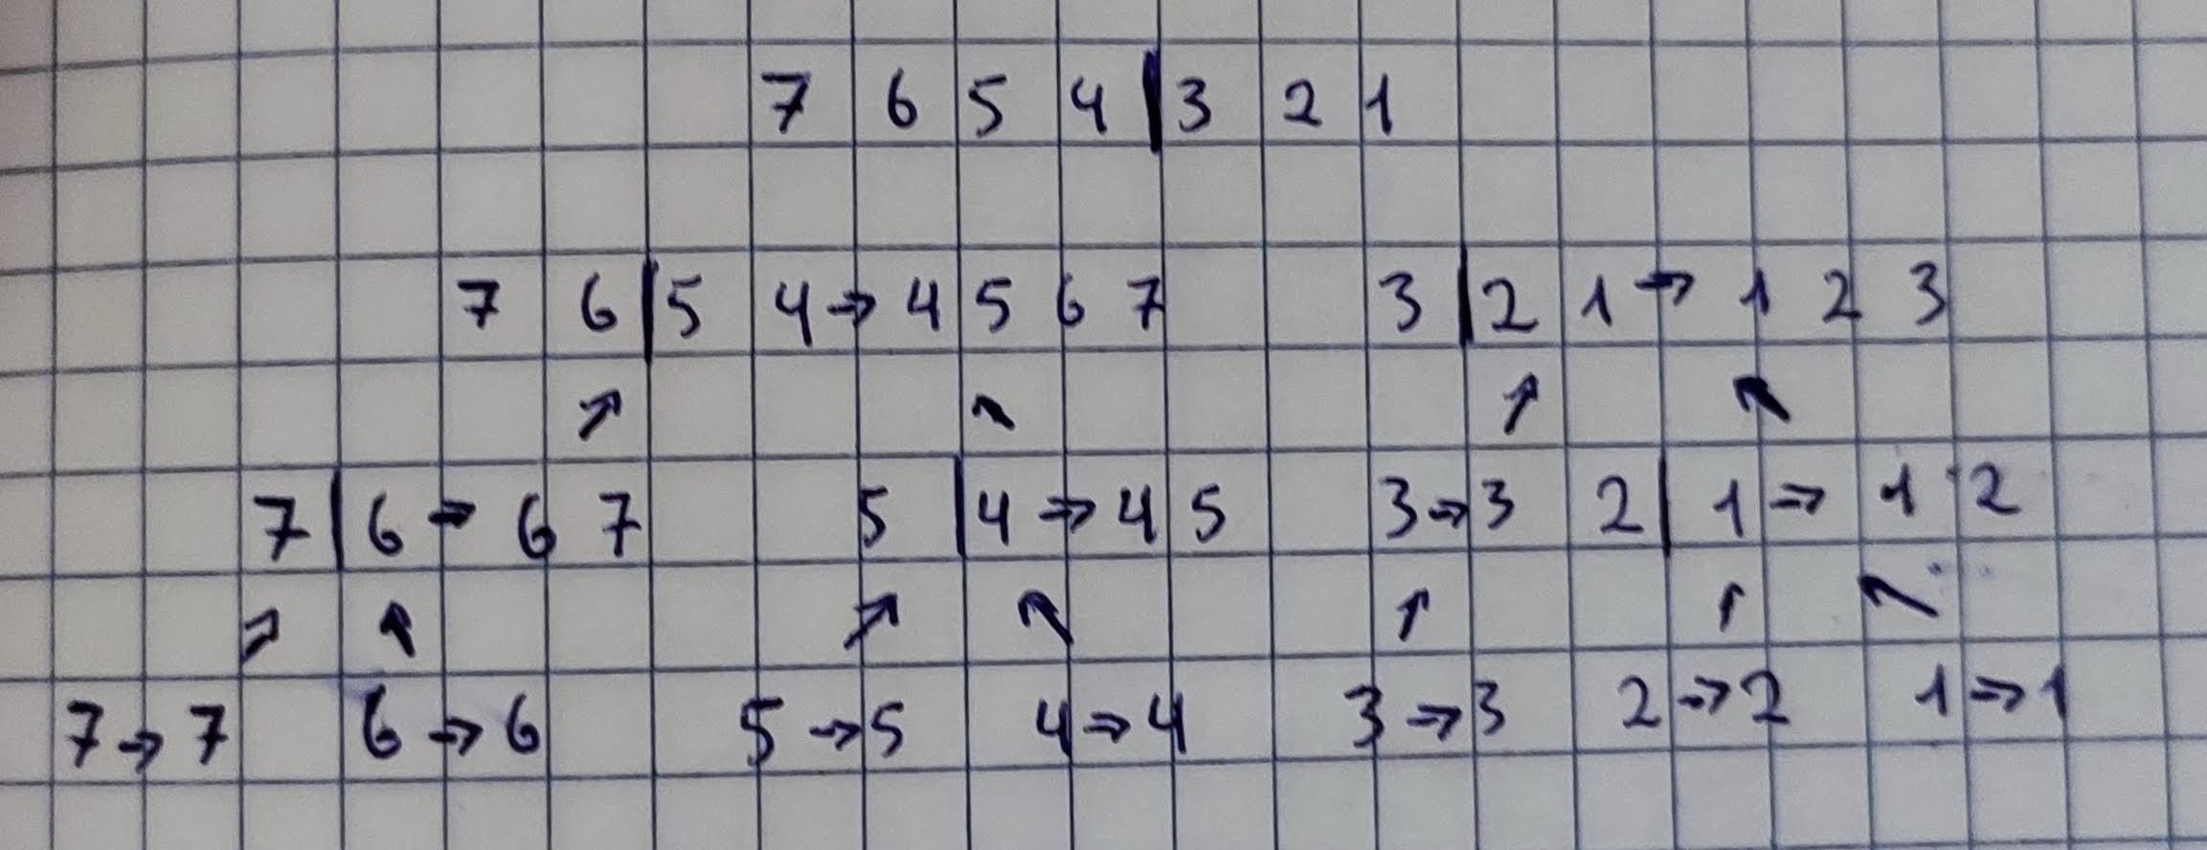

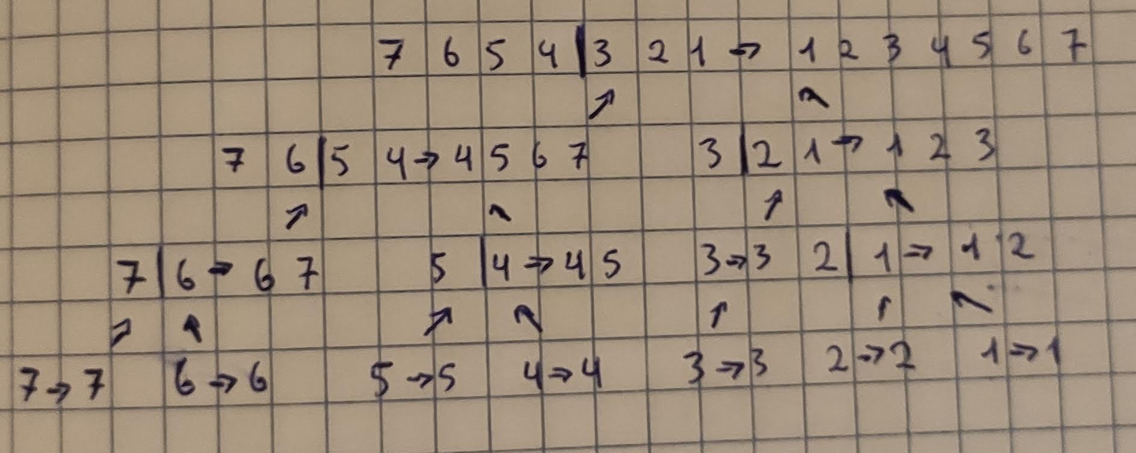

1. **Sometimes MergeSort is supplemented with a secondary sorting routine (typically, InsertionSort is used) in the following way: During the recursion in MergeSort, the size of the array being sorted becomes smaller and smaller. To create a hybrid sorting routine, when a recursive call requires the algorithm to process an array with 20 or fewer elements, give this array to InsertionSort and patch in the result after it has finished. Call this hybrid algorithm MergeSortPlus.** 
   1. **Express the steps of MergeSortPlus in the pseudo-code language we are using in class.**

**Algorithm *mergeSort***(***S***)  
 **Input** sequence ***S*** with ***n integers***

**Output** sequence ***S*** sorted

**if *S.size***() **>** 1 **then**

**If S.size() < 20 then**

**InsertionSort()**

**else**

(***S***1, ***S***2) <- ***partition***( S, n/2)

***mergeSort***(***S***1)

***mergeSort***(***S***2)

***S <-*** ***merge***(***S***1, ***S***2)

**return** *S*

* 1. **Write the Java code for MergeSortPlus (use the implementation of MergeSort provided in the lab folder)**

**////////////// code ////////////////**

public class MergeSortPlus extends Sorter {

final int ARRAY_SIZE = 33;

final int MAX_VAL = 1000;

int[] theArray;

//public sorter

public int[] sort(int[] input){

int n = input.length;

int[] tempStorage = new int[n];

theArray = input;

mergeSort(tempStorage,0,n-1);

return theArray;

}

void mergeSort(int[] tempStorage, int lower, int upper) {

if(lower==upper){

return;

}

if(upper-lower <= 20){

insertionSort(lower,upper);

} else {

int mid = (lower+upper)/2;

mergeSort(tempStorage,lower,mid); //sort left half

mergeSort(tempStorage,mid+1, upper); //sort right half

merge(tempStorage,lower,mid+1,upper); //merge them

}

}

/** Merges the ranges [lower, mid] and [midPlusOne,upper] in place */

private void merge(int[] tempStorage, int lower, int midPlusOne, int upper) {

int pos = 0; //tempStorage index

int i = lower;

int j = midPlusOne;

int n = upper - lower + 1; //total number of elements to rearrange

//view the range [lower,upper] as two arrays

//[lower, mid], [midPlusOne,upper] to be merged

while(i < midPlusOne && j <= upper){

if(theArray[i] <= theArray[j])

tempStorage[pos++] = theArray[i++];

else

tempStorage[pos++] = theArray[j++];

}

while(i < midPlusOne) {

tempStorage[pos++] = theArray[i++];

}

while(j <= upper){

tempStorage[pos++] = theArray[j++];

}

//replace the range [lower,upper] in theArray with

//the range [0,n-1] just created in tempStorage

for(j=0; j<n; ++j) {

theArray[lower+j] = tempStorage[j];

}

}

private void insertionSort(int lower, int upper) {

if(theArray == null || theArray.length <= 1)

return;

int temp = 0;

int j = 0;

for(int i = lower; i <= upper; ++i) {

temp = theArray[i];

j=i;

while(j>lower && temp < theArray[j-1]){

theArray[j] = theArray[j-1];

j--;

}

theArray[j]=temp;

}

}

//set up routines

public static void main(String[] args){

MergeSortPlus ms = new MergeSortPlus();

//ms.testMerge();

int[] arr = {1,4,2,5,6,1,7,9,0};

int[] returnArr = ms.sort(arr);

for (int i : returnArr) {

System.***out***.print(i + " ");

}

}

}

* 1. **Run tests to compare running times of MergeSort and MergeSortPlus. Which one runs faster? Explain how you tested and whether you feel your results are conclusive.**

70 ms -> MergeSortPlus

84 ms -> MergeSort

To test the algorithm I increment the values

private final int[] ARRAY_SIZES = {50000,10000,4000, 5000}

The results are expected because MergeSortPlus has two algorithm in one

1. ***Binary Trees.* A *binary tree* is a tree in which every node has at most two children.** 
   1. **Write out 4 different binary trees, each having height = 3 – make sure that no two**  **of your trees have the same number of nodes. (There is no need to give labels to**  **the nodes.)**

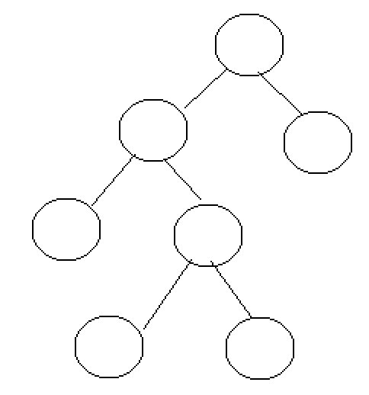

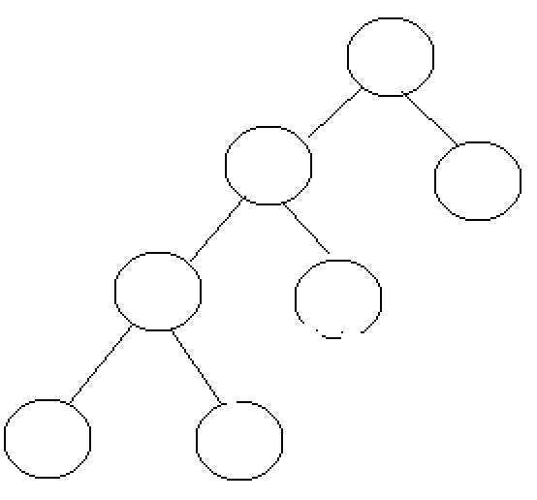

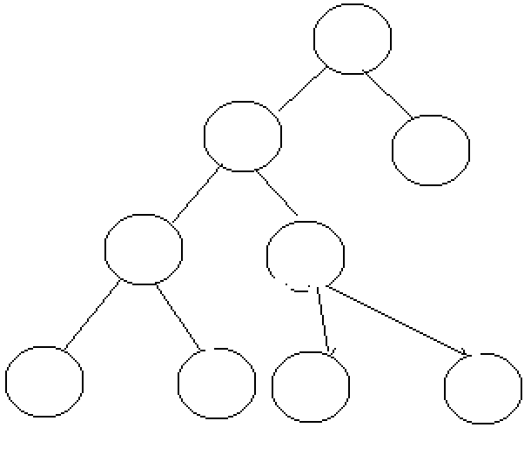

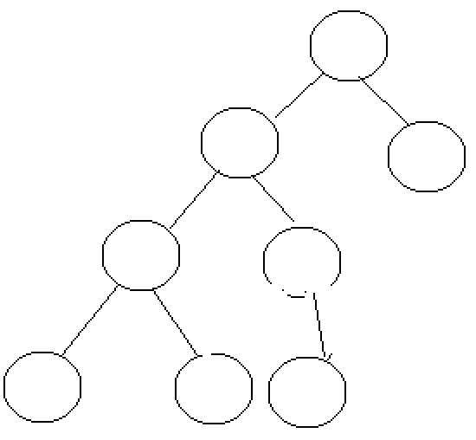

* 1. **Examine the trees you have drawn and decide whether the following statement is true or false:**

***Every binary tree of height 3 has at most 23=8 leaves.***

true

* 1. **Based on your answer to b, what do you think is true in general about the number of leaves of a binary tree of height *n*?**

The heigth of binary tree has at most 2ⁿ leaves